Armon Wilson

SNHU

CS-230 Operating Systems

01/20/2024

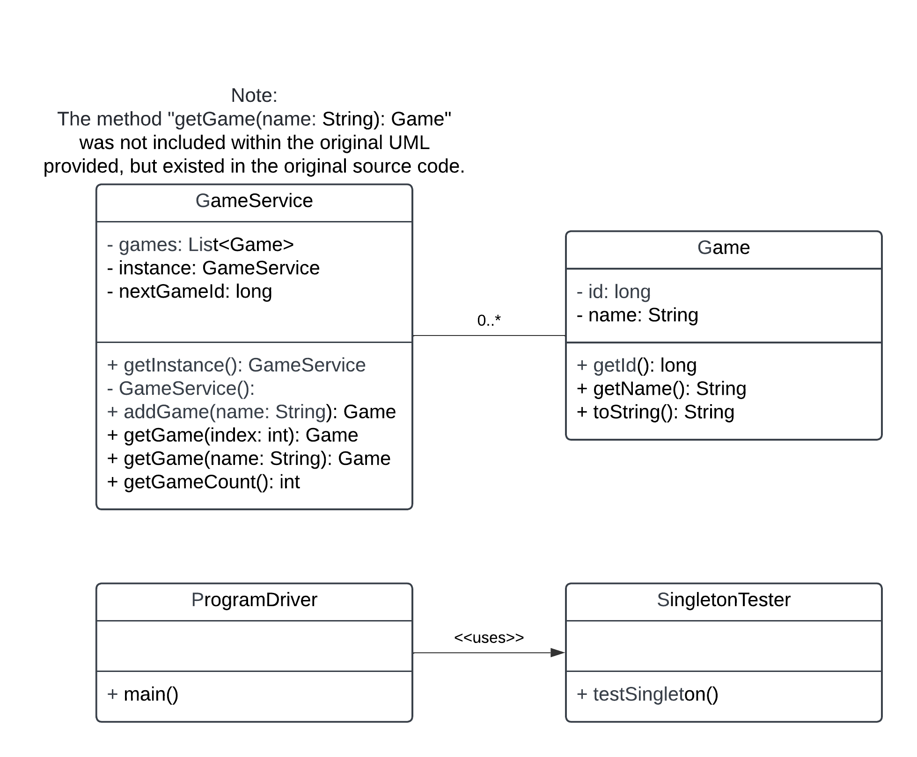

<<uses>>

Explanation of patterns used (Singleton and Iterator) can be found in the GameService class file as notes.